# **PEEE I Practical Session 4**

Power and Energy

________________________________________________________________________

**1. OBJECTIVE**

* To measure voltages and currents in a circuit for power and energy calculations.

**2. EQUIPMENT**

* DC power supply.
* Digital Multimeters (DMMs).
* Training kit with 1 k, 2.2 k, 3.3 k and 4.7 k resistors.

**3. PROCEDURE**

3.1 PART 1: Measure and Calculate Power Dissipated by a Resistor

3.1.1 **Turn on** the power supply by pressing down the **POWER button** at the bottom left corner of the power supply panel.

3.1.2 The output of the power supply can be enabled and disabled by toggling the **OUTPUT button** on top of the POWER button. The ON/OFF green LED under the output button indicates whether the output is enabled/disabled.

Ensure that the output of the power supply is disabled now and the **ON/OFF green LED** is **OFF**.

3.1.3 Set the **CURRENT knob** of CH1 approximately to the **9 o’clock position** (See Figure 4.1). This limits the output current not to be too high. The **C.V. green LED** besides the CURRENT knob should be **lighted up** throughout the experiment.

**Note:** Do not confuse the ON/OFF green LED with the C.V. green LED. They are two different LEDs.

3.1.4 Connect the circuit as shown in Figure 4.1. Set power supply to about 10 V.

This is the normal position of the circuit breaker switch.

If it extends up to break high current, disconnect the meter and press down the switch to resume operation.

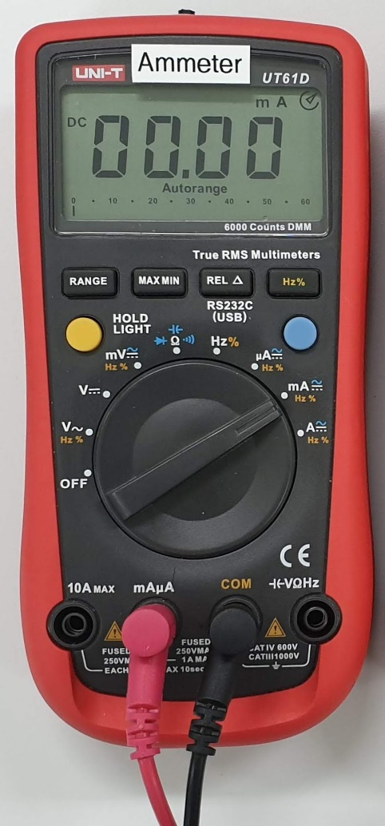 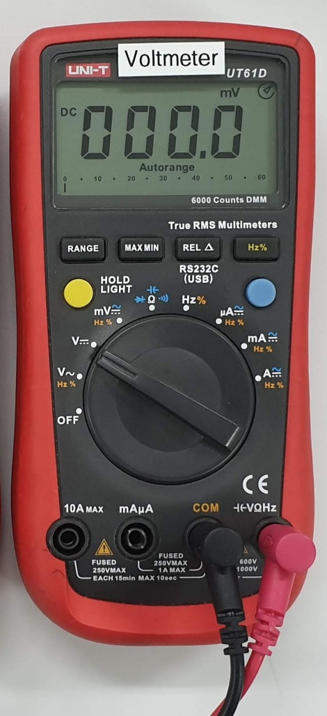

Use DMM as an ammeter Use DMM as a voltmeter

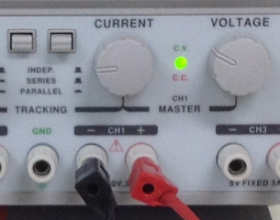

+

−

mA

$I$

+

−

+

$$R$$

$$V_{S}$$ ≈10 V

V``

−

Refer Table 4.1 for resistance value.

Figure 4.1 One-resistor circuit

HBL note: Construct the above circuit using Multisim and run the simulation, as shown in Figure 4.1a. (The steps are similar to what you did in Practical Session 3. So you can either do it from memory or follow the steps below to construct the circuit shown.)

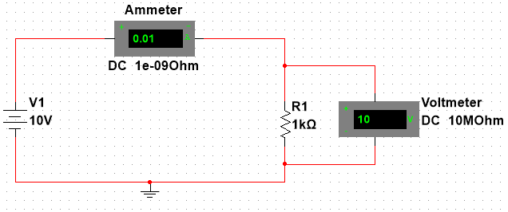

Fig 4.1a

1 Launch Multisim.

2 Select Place | Component from the menu. (This is the Component Browser.) The Component Browser is used to select components for placement onto the schematic.

3 This schematic needs the following components from the Master Database.

1. **Resistors** from the **Basic** Group.
2. Ground from the **Sources** Group > **POWER_SOURCES** > **GROUND**
3. DC supply from the **Sources** Group > **POWER_SOURCES** > **DC_POWER**
4. Voltmeter U1 from the **Indicators** Group> **VOLTMETER > VOLTMETER_V**
5. Ammeter U2 from the **Indicators** Group> **AMMETER > AMMETER_H**

You should get something like Fig 4.1b

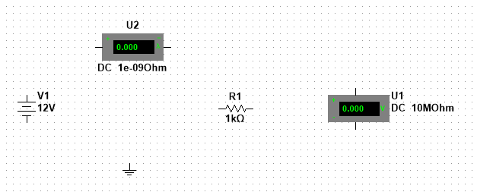

Fig 4.1b

4a You can change the property of the component by selecting the component (left click the mouse) and then right click the mouse and select Properties. You may need to rotate some of the components for a preferred placement position. This can be done by selecting the component and then right click on the mouse.

4b Right click on the Resistor and select Rotate 900 clockwise.

You should get something like Fig 4.1c

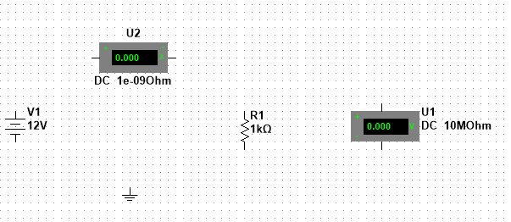

Fig 4.1c

5 Now, you need to connect the components together to form the circuit. Place the cursor at the pin of the components and the cursor will turn into a cross and drag it to the other end of the component to be connected.

You should get something like Fig 4.1d

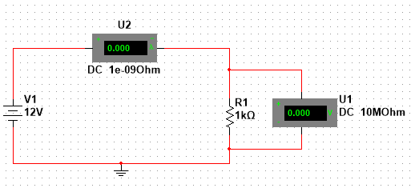

Fig 4.1d

6 In Fig 4.1d, U1 is the Voltmeter and U2 is the Ammeter. So let us make some changes to make this clear.

6a Double click on U1 and select the Label tab. Change the RefDes from U1 to Voltmeter.

6b Double click on U2 and select the Label tab. Change the RefDes from U2 to Ammeter.

7 The voltage from the power supply is supposed to be 10 V But the wrong value of 12 V was selected earlier.

7a Double click on the DC_POWER and select the Value tab. Change the Voltage to 10 V.

You should get something like Fig 4.1e



Fig 4.1e

8 Select Simulate | Run to start the simulation. Record the value of the current in Table 4.1

9 Change the value of resistor, re-run the simulation and fill up Table 4.1.

**Note that the part in green (for HBL) replaces 3.1.1 to 3.1.8 (first line) of this Practical. You still have to do 3.1.9 (second line) onwards, using the data from Mutlisim.**

3.1.5 Ask your lecturer to check your circuit.

3.1.6 Press the **OUTPUT button** of the power supply to power up the circuit. The **ON/OFF green LED** under the output button should be **lighted up** now.

3.1.7 Measure the voltage and current of the 1 k resistor. Fill in Table 4.1.

3.1.8 Repeat step 3.1.7 with the other resistances and complete Table 4.1.

**Note:**

Thermal power dissipation in a resistor can be calculated by these formulas:

, ,

1 k, 2.2 k, 3.3 k and 4.7 k are the nominal resistances of the resistors. They are not the actual resistances. The tolerance of the resistors used in this experiment is ±5%.

The **actual resistance** is expected to be a value in the range of **nominal resistance ±5%**.

The **calculated resistances $R=\frac{V}{I}$** are closer to the **actual resistances**. Use these calculated resistances to calculate power in Table 4.1.

|  |  |  |  |  |  |  |
| --- | --- | --- | --- | --- | --- | --- |
| **Resistor** | ***I* (mA)** | ***V* (V)** | $R=\frac{V}{I}$**(kΩ)** | **Power (mW)** | | |
|  |  |  |
| 1 k |  |  |  |  |  |  |
| 2.2 k |  |  |  |  |  |  |
| 3.3 k |  |  |  |  |  |  |
| 4.7 k |  |  |  |  |  |  |

## Table 4.1: Power computations

3.2 PART 2: Measure and Calculate Power Dissipation and Energy Consumption in a Circuit

3.2.1 Disable the output of the power supply by pressing the **OUTPUT button** on top of the POWER button. Check whether the **ON/OFF green LED** is **OFF**.

3.2.2 Connect the circuit as shown in Figure 4.2.

**+**

**_**

*V*S

≈10 V

*I*T

Figure 4.2 Two-resistor circuit

1 k

2.2 k

*V*1

*V*2

**+**

**_**

**+**

**_**

HBL note: Construct the above circuit using Multisim and run the simulation, as shown in Figure 4.2a. (It may be easier to save the Multisim file you created earlier and modify it e.g. as shown in the steps below.)

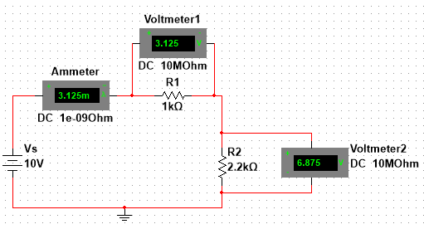

Fig 4.2a

1 Save the file that you created earlier under a different name. Delete the wires (shown in red).

2 Select Place | Component from the menu. (This is the Component Browser.) The Component Browser is used to select components for placement onto the schematic.

3 This schematic needs the following components from the Master Database.

1. **Resistors** from the **Basic** Group.
2. Ground is already there from the previous circuit.
3. DC supply is already there from the previous circuit.
4. Voltmeter from the **Indicators** Group> **VOLTMETER > VOLTMETER_V** (It is already there from the previous circuit.)
5. Voltmeter U1 from the **Indicators** Group> **VOLTMETER > VOLTMETER_H**
6. Ammeter is already there from the previous circuit.

You should get something like Fig 4.1b

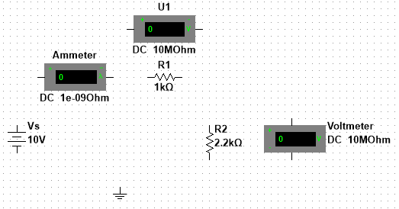

Fig 4.2b

4 Now, you need to connect the components together to form the circuit. Place the cursor at the pin of the components and the cursor will turn into a cross and drag it to the other end of the component to be connected.

You should get something like Fig 4.2c

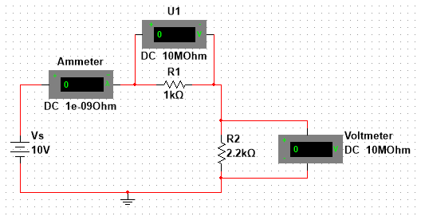

Fig 4.2c

5 In Fig 4.2c, U1 is the first Voltmeter and Voltmeter is the second Voltmeter. So let us make some changes to make this clear.

(In the actual lab, you will only have one Voltmeter. In order to measure the voltages across 2 resistors, you have to measure the voltage across the first resistor. Disconnect the Voltmeter. Then measure the voltage across the second resistor.)

5a Double click on U1 and select the Label tab. Change the RefDes from U1 to Voltmeter1.

5b Double click on Voltmeter and select the Label tab. Change the RefDes from Voltmeter to Voltmeter2.

You should get something like Fig 4.1d

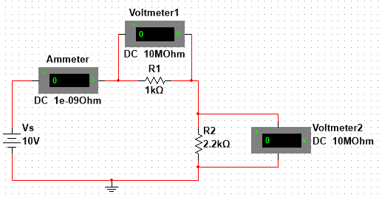

Fig 4.1d

6 Select Simulate | Run to start the simulation. Record the value of the current and voltages in Table 4.2

**Note that the part in green (for HBL) replaces 3.2.1 to 3.2.5 of this Practical. You still have to do 3.2.6 onwards, using the data from Mutlisim.**

3.2.3 Ask your lecturer to check your circuit.

3.2.4 Press the **OUTPUT button** of the power supply to power up your circuit. Check whether the **ON/OFF green LED** is **lighted up**.

3.2.5 Using Figure 4.1 as a guide, connect an ammeter and a voltmeter to measure current *I*1 and voltage *V*1 of the 1 k resistor. Fill in the values of *I*1, *V*1, *P*1 and *W*1 in Table 4.2.

3.2.6 Fill in the **theoretical** values for ***I*2, and *I*T** in Table 4.2 **according to** the measured value of *I*1.

3.2.7 Measure the voltages across the 2.2 k resistor and the power supply. Fill in the whole Table 4.2.

|  |  |  |  |  |  |
| --- | --- | --- | --- | --- | --- |
| Circuit element | Current  (mA) | Voltage  (V) | Power $$P=V×I$$ (mW) | Energy consumption in 1 hour | |
| $$W=P\left(in W\right)×t\left(in s\right)$$ (J) | (mWh) |
| 1 k |  |  |  |  |  |
| 2.2 k |  |  |  |  |  |
| Power supply | $I_{T}$ | $V_{S}$ | $P_{T}$ | $$W_{T}$$ | $$W_{T}$$ |

Table 4.2 Power and energy computations

3.2.8 The computations in Table 4.2 show that

* The total power dissipated in the circuit = *P*1 + *P*2 = ______________ .
* The power delivered from the power supply = *P*T = ______________ .
* The power delivered to a circuit ___________________ the total power dissipated in the circuit.
* The total energy consumed in 1 hour = *W*1 + *W*2 = __________ J.
* The total energy consumed in 1 hour can also be expressed as __________ mWh.

|  |  |
| --- | --- |
|  | In what form does a resistor dissipate the energy?  ____________________________________________________________ |

**4. CONCLUSION**